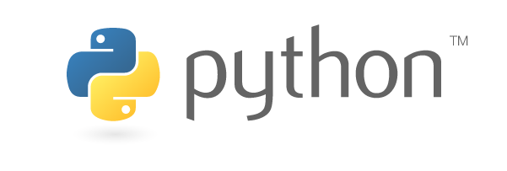

TOOLS AND TECHNIQUES LAB ACTIVITY - T1

Topic – Flappy Bird Game

GROUP - 03

Members:-

ARYAN DEV – 2005716

SHREST RAJ (2005759)

UTKARSH GARG (2005348)

SHOBHIT SHUKLA (2005611)

PRATYUSH SRIVASTAVA (2005740)

DESCRIPTION:-

In this Project, we are going to see how to make a flappy bird game in Pygame.

We all are familiar with this game. In this game, the main objective of the player is to gain the maximum points by defending the bird from hurdles. Here, we will build our own Flappy Bird game using Python.

We will be using Pygame(a Python library) to create this Flappy Bird game. **Pygame** is an open-source library that is designed for making video games. it helps us to create fully functional games and multimedia programs in python.

SOUCE CODE LINK:-

https://www.geeksforgeeks.org/how-to-make-flappy-bird-game-in-pygame/

**ROUGH OUTLINE OF THE PROJECT:-**

**Step 1:**In this first step, we have to import libraries and initialize pygame. We have to set the height and width of the screen to which the game will be played. Now we have to define some images which we shall use in our game like pipes as hurdles, birds images, and also a background image of the flappy bird game.

**Step 2:** Make the bird, pipes and the background with a land.

Here Clock() will be used further in the main loop of the game to alter the speed the bird.

**Step 3:**Initialize the position of the bird and starting the game loop.

Initialize the position of bird and sea level to the ground. Adding conditions in the loop defines the game conditions. The variable horizontal and vertical is used to set the position of the bird.

**Step 4:** Create a function that generates a new pipe of random height. We have to fetch the height of the pipe and after that this generates a random number between 0 to a number (such that the height of the pipe should be adjustable to our window height).

**Step 5:** Now we create a **GameOver()** function which represents whether the bird has hit the pipes or fall into the sea. Three conditions lead to a situation of the game over. If the difference between our elevation and a certain height is less than vertical it means the bird has crossed its boundaries resulting in a game over and if the bird hits any of the lower and upper pip then this will also lead to game over condition.

**Step 6:**Now we will be creating our main function (**flappygame()**) that will do the following things:

Create two lists first is of lower pipes and the other is of lower pipes. Defining the bird velocity, minimum bird velocity, maximum bird velocity, and pipes velocity. Handle the key events using **pygame.event.get()** and checking for the game is over or not if it is over return from the function. Updating the score and blit game images such as background, pipe, and bird on the window.

ENHANCEMENTS :-

1. **Adding a welcome screen** to the game where user can use use spacebar to start the game instead of directly starting the main game.
2. As we already know many developers were unable to succeed in such games. One of the major reason was the lack of attractiveness in the game. Flappy bird is always so boring, so **upgrading the shape and colour of the flappy bird to a helicopter** making it more attractive to players.
3. Building a very **cool virtual environment** to interesting theme like buildings instead of pipes which will keep all the age group of users engaged.
4. **Adding high score to compare all players** ever played this game and displaying information if the player beat the high score ever made or is he lacking behind.
5. **Adding sound to all the activities** in the game as the game is too boring without any sound and make it very fun and interesting.
6. **Adding 3 levels of different difficulty** because the game has been always too easy for players, so that there will be real competition.